STATUS REPORT – Will Wu

Writer | Will Wu
Status Update Period | Week of 04/02/23 - 04/08/23
Professor | Dr. Dorothy Wang
Accomplishments for the week of (04/02/23-04/08/23)
- RPM Peripheral
  - I finished the RPM peripheral this week. The peripheral connects to the raspberry pi via USB (serial) and constantly publishes RPM reading through serial.
  - The driver on the Raspbery Pi side will read one line from the serial bus as the publisher commands
- Kalman Filter design and implementation is underway
  - There are three Kalman Filter under design: x velocity estimate, y velocity estimate, and yaw angle estimate
  - Each kalman filter will have a simple double integrator as its process model, IMU inputs as process input, and GPS/encoder data as measurement input.
  - We have verified the initial design in MATLAB.
- System Tests
  - To assist with kalman filter design and testing, we have conducted several tests.
  - We configured the ROS bag and Plotjuggler to analyze system signals. See page 2 for results
  - Onja and Payton have set up the GPS node. We will be converting that into a publisher node.

Plan for next week (04/02/23-04/08/23)
- Conduct system tests, verify Kalman Filter performance
- Design and verify GPS/IMU fusion algorithm
- Implement basic PID velocity controllers

Topic Outline/ Progress toward deliverables
- PID Controller, linear estimator and angular estimator design. 30% done; ongoing: 2/24/23 - 4/8/23
- Kalman Filter ROS2 implementation. 20% done; ongoing: to complete by 4/15/23
- Testing Scheduled: 4/01/23 – 4/20/23
- Landmark based SLAM study Scheduled 4/01/23 – 4/27/23
Issues
- None this week

Kalman filter design via MATLAB/Simulink
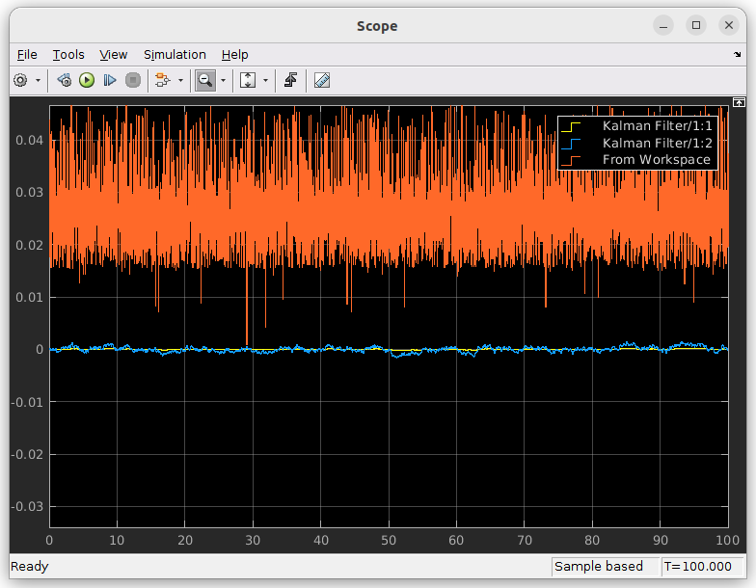
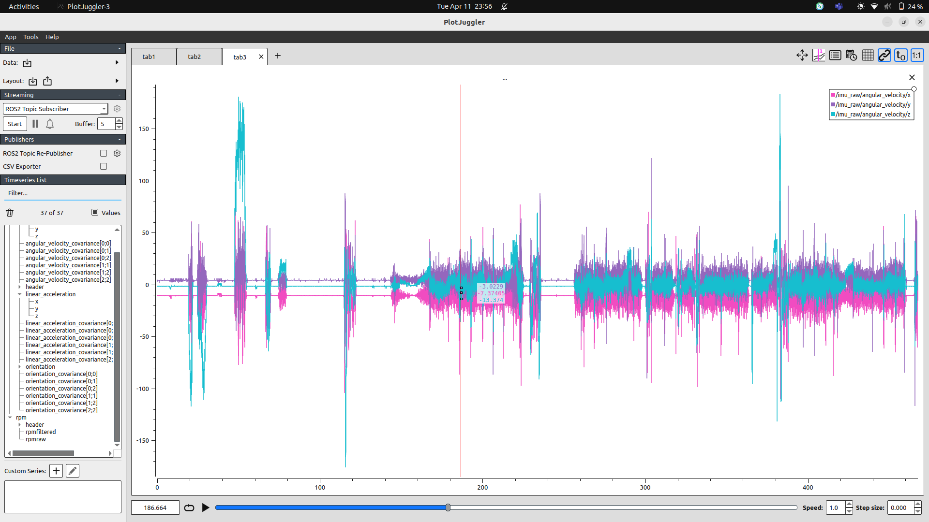
Plotjuggler for picar test data

